BIOLOGICAL SCIENCES

CAMP ASSESSMENT 2015

Name: _________________________ Mark: /25

1. The effect of climate change has already been observed in the form of lower rainfall and higher temperatures in the SW of Western Australia. Give two other effects that will occur as a result.

(2 marks)

________________________________________________________________

________________________________________________________________

1. Identify these weeds of the WA wheatbelt. (2 marks)

a) _________________________ b) _______________________

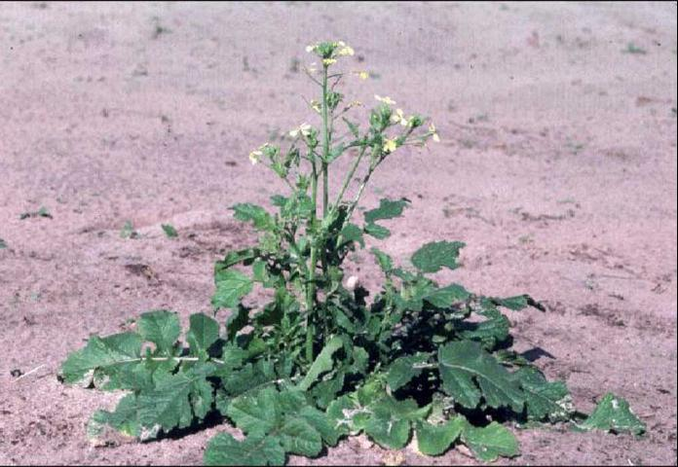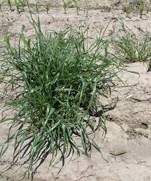

1. a) What creates herbicide resistent weeds? (2 marks)

________________________________________________________________

________________________________________________________________

________________________________________________________________

b) Describe one way in which farmers can still use herbicides but not create resistance. (1 mark)

________________________________________________________________

________________________________________________________________

c) Describe two ways in which farmers can avoid the use of herbicides to control weeds. (2 marks)

________________________________________________________________

________________________________________________________________

________________________________________________________________

1. What is the chemical name for the herbicide Roundup?

__________________________________ (1 mark)

1. a) Explain what the ASBV is and how can it be used to improve productvity in a flock of sheep? (3 marks)

________________________________________________________________

________________________________________________________________

________________________________________________________________

________________________________________________________________

________________________________________________________________

________________________________________________________________

1. Male sheep are not kept on the farm unless they are to be used for breeding.

Apart form wool production explain one desirable characteristic that the farmer would select for in rams and explain why. (2 marks)

________________________________________________________________

________________________________________________________________

________________________________________________________________

1. During the camp we observed Kalyx, a private research company, conducting crop trials with herbicide resistant varieties of canola plants. These experiments must be carried out according to scientific method if they are to be accepted in the scientific community.

a) What was the dependent variable in this experiment? (1 mark)

______________________________________________________________

b) There were actually two independent variables being tested. What were these?

(2 marks)

________________________________________________________________

________________________________________________________________

c) Describe using examples, how **two** features of scientific method were being used in the crop trials. (2 marks)

________________________________________________________________

________________________________________________________________

________________________________________________________________

________________________________________________________________

1. Farmers are constantly reviewing their inputs and productivity in order to maximise their income. Describe **two** **different** ways the Department of Agriculture can help farmers to either reduce costs or increase productivity.

(2 marks)

________________________________________________________________

________________________________________________________________

________________________________________________________________

________________________________________________________________

________________________________________________________________

________________________________________________________________

1. a) Native plants are said to be allelopathic. What does this mean? (1 mark)

________________________________________________________________

________________________________________________________________

b) How can these be used to prevent herbicide resistance? (2 marks)

________________________________________________________________

________________________________________________________________

________________________________________________________________

________________________________________________________________